Mkoba User Manual
Oct 22, 2026 · @Oporo.ke
This manual teaches you to keep your business records with Mkoba, step by step, on WhatsApp and on the web. It covers Mkoba version 1.0 as built and tested on 22 October 2026.
Item | Detail
Product | Mkoba: business records on WhatsApp
Manual version | 1.0
Revision date | 22 October 2026
Readers | Vendors (business owners) and the Mkoba administrator
Language of this manual | English. Mkoba itself answers in Swahili or English.

Contents
- Introduction
- Getting started
- Understanding Mkoba's screens
- Recording sales, purchases and expenses
- Confirming, correcting and deleting entries
- Summaries and evening reports
- Debts
- Pasting mobile-money SMS
- The web dashboard
- Business statement for lenders
- Language, privacy and your data
- End-to-end workflows
- Managing your records
- Messages Mkoba sends you
- Administrator guide
- Troubleshooting
- Frequently asked questions
- Glossary
- Quick reference
- Help and support
Appendix A: Feature coverage matrix · Appendix B: Known limitations and unresolved questions · Appendix C: Manual validation report · Appendix D: Version history

1. Introduction
Mkoba keeps the records of a small business through ordinary WhatsApp messages. You write what you sold, bought or spent, the way you would tell a friend, and Mkoba saves it and adds it up for you.

1.1 What Mkoba does
- Saves your sales (mauzo), purchases (manunuzi) and expenses (matumizi) from short messages such as nimeuza chips 5000.
- Tells you your profit or loss (faida / hasara) for today, yesterday, this week, this month or all time.
- Keeps a debt book (madeni): who owes you, whom you owe, and payments.
- Sends you a summary every evening at 9 pm (Tanzania time), if you recorded something that day.
- Shows your records on a web page (the dashboard) on your phone's browser.
- Makes a business statement you can show a lender or SACCO.
- Reads Airtel Money payment SMS that you paste into the chat.

1.2 Problems it solves
- Records kept in a notebook get lost, wet or are hard to add up. Mkoba adds up for you.
- Many vendors do not know their real profit. Mkoba subtracts purchases and expenses from sales.
- Customers forget their debts. Mkoba remembers them and gives you a polite reminder to forward.
- Lenders ask for proof of income. Mkoba's statement shows six months of your records.

1.3 Who uses Mkoba
Role | Who it is | What they do | Chapters
Vendor | A business owner: food seller, shopkeeper, market trader | Records sales, purchases, expenses and debts; reads summaries; uses the dashboard and statement | 2 to 14
Administrator | The person who runs Mkoba (the owner of the service) | Watches usage on the admin page; reviews messages Mkoba did not understand; checks the server | 15
There are no other roles. Every vendor has the same features. A vendor can only ever see their own records.

1.4 What you need before you start
- A mobile phone with WhatsApp installed and working.
- Internet on that phone (mobile data or Wi-Fi).
- The Mkoba WhatsApp number: +255 788 001 168.
- For the web dashboard and statement: a web browser on your phone or computer (for example Chrome).
You do not need an app, a password or an email address.

1.5 Supported devices
- WhatsApp chat: any phone where WhatsApp works.
- Web pages (dashboard, statement, privacy page): tested in Chrome on a phone-sized screen (360 and 390 pixels wide) and on a computer screen.

1.6 Important limitations
- Mkoba understands text messages only. It cannot listen to voice notes or read photos.
- Amounts are in Tanzanian shillings (TSh) only.
- Pasted payment SMS: only Airtel Money Tanzania payments you make are read today. Money you receive by SMS, and Vodacom M-Pesa or Mixx by Yas messages, are not read yet (see Appendix B).
- The web dashboard is in Swahili only.
- Your records are what you type. Mkoba does not check them against your till or bank.

1.7 How to use this manual
- New vendor: read chapters 2 and 4 first, then 6.
- Look up a task in the Contents and follow its numbered steps in order.
- Text in this style is exactly what you type into WhatsApp. Capital or small letters do not matter.
- Lines that start with Mkoba replies: show what you will see. Your amounts and names will differ.
- Chapter 19 lists every command on one page.

1.8 A few words you will meet
Word | Meaning
Entry | One saved record, such as one sale
Mauzo | Sales: money coming in from selling
Manunuzi | Purchases: buying stock to sell
Matumizi | Expenses: other costs, such as transport or rent
Faida / Hasara | Profit / Loss: sales minus purchases and expenses
Madeni | Debts
Dashibodi | The dashboard: your records on a web page
The full list is in chapter 18 (Glossary).

2. Getting started
You start Mkoba by sending any WhatsApp message to +255 788 001 168, agreeing to how your data is used, and answering two questions. It takes about two minutes. There is no app to install and no password.

2.1 Save the Mkoba number (optional but helpful)
Purpose: find the Mkoba chat quickly later.
- Open your phone's Contacts (or Phone) app.
- Tap the button to add a new contact (often a + sign).
- In the name field, type Mkoba.
- In the phone number field, type +255 788 001 168.
- Tap Save.
Result: Mkoba now appears in your contacts and in WhatsApp's contact list.

2.2 Send your first message
Before you begin: WhatsApp is working and you have internet.
- Open WhatsApp.
- Tap the new chat button (a message icon, usually at the bottom right).
- Find Mkoba in the list and tap it. If you did not save the number, search for it or open a chat with +255 788 001 168.
- In the message box at the bottom, type a greeting, for example habari (Swahili) or hello (English).
- Tap the send button (the arrow).
- Wait a few seconds for the reply.
Mkoba replies with a welcome and a short notice about your data, in the language you wrote in:
Karibu Mkoba! 👋 Nitakusaidia kuweka hesabu za biashara yako kupitia WhatsApp. Ili kufanya hivyo, Mkoba itahifadhi namba yako ya simu, jina lako, na rekodi unazotuma (mauzo, manunuzi, matumizi, madeni). [...] Unaweza kuzifuta zote wakati wowote kwa kuandika FUTA DATA. Soma zaidi: https://mkoba.digital/faragha Jibu NAKUBALI kuendelea.
Important: until you agree (2.3), Mkoba saves nothing you send. If your first message was a sale such as nimeuza 5000, it is not recorded. Send it again after you agree.

2.3 Agree to how your data is used
Purpose: Mkoba needs your permission before it keeps any records.
- Read the notice. To read the full privacy page, tap the link in the message (see 11.3).
- Reply with NAKUBALI (Swahili) or I AGREE (English). ndio and yes also work.
- Wait for the reply.
Mkoba replies: Asante! Kwanza, jina lako ni nani? (English: Thank you! First, what's your name?)
If you reply anything else, Mkoba repeats a shorter reminder and the link, and saves nothing. Photos and voice notes get the same reminder.

2.4 Tell Mkoba your name
- Type your name, for example Asha. You can also write naitwa Asha, jina langu ni Asha or my name is Asha.
- Send it.
Rules for the name: up to 4 words, no numbers. A greeting such as habari is not taken as a name.
Mkoba replies: Asante Asha! Unafanya biashara gani? (mfano: chakula, duka, mboga, nguo) and Andika "ruka" kuruka swali hili.
If you send something that is not a name (for example a sale with a number in it), Mkoba handles that message normally and keeps waiting for your name. Send your name when ready.

2.5 Tell Mkoba your type of business
- Type your business in a few words, for example chakula, mama lishe, duka la nguo or nauza mboga.
- Send it.
To skip this question, send ruka (English: skip).
Rules: up to 6 words, no numbers.
Mkoba replies: Safi, Asha! Sasa uko tayari. followed by the list of commands (the same list you get by sending msaada).
Result: you are set up. Go to chapter 4 to record your first sale.

2.6 If you already used Mkoba before October 2026
Vendors who joined before the privacy feature are asked to agree once. The next time you write, Mkoba replies with the reminder and the link. Reply NAKUBALI. Mkoba replies Asante! Sasa unaweza kuendelea kutumia Mkoba. Your old records are kept; send your message again.

2.7 Coming back later
There is nothing to log in to. Open the Mkoba chat in WhatsApp and type. Mkoba remembers your name, language and records.

2.8 Stopping
- To stop the evening summary only: send ACHA RIPOTI (see 6.6).
- To delete everything Mkoba holds about you: see 11.4. This cannot be undone.
- Simply not writing is also fine; nothing happens to your records.

3. Understanding Mkoba's screens
Mkoba has one place where you do the work, the WhatsApp chat, and four web pages you only read. All screenshots below are from the real application with made-up demonstration data (vendor "Asha Demo").
Screen | What it is for | How to open it | Who uses it
WhatsApp chat | Recording everything and asking for summaries | WhatsApp, chat with +255 788 001 168 | Vendor
Dashboard (Dashibodi) | Seeing profit, a 14-day chart, recent records and debts | Send dashibodi, open the link (chapter 9) | Vendor
Business statement | Showing a lender six months of figures | Send taarifa ya biashara, open or share the link (chapter 10) | Vendor, lender
Privacy page | Reading how your data is used | Link in the welcome message, or https://mkoba.digital/faragha | Anyone
Admin page | Watching usage and parser quality | https://mkoba.digital/admin with the admin password | Administrator

3.1 The WhatsApp chat
The chat is an ordinary WhatsApp conversation. There are no buttons or menus. You type a message, send it, and Mkoba answers within a few seconds.
- Your messages appear on the right.
- Mkoba's replies appear on the left. A reply that starts with Sawa! (Done!) means something was saved or changed.
- A reply that ends with Jibu NDIO au HAPANA (Reply YES or NO) means Mkoba is waiting for you before saving (chapter 5).
- A reply that starts with Samahani (Sorry) means Mkoba did not understand or could not do what you asked; it tells you what to send instead.
To see every command, send msaada (English: help).

3.2 The dashboard
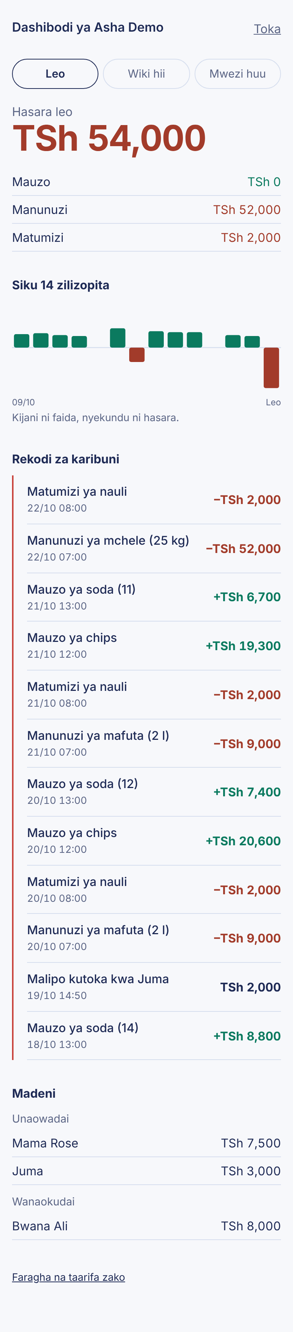
From top to bottom:
- Title (Dashibodi ya Asha Demo) and Toka (log out) at the top right.
- Period buttons: Leo (today), Wiki hii (this week), Mwezi huu (this month). The one with a dark border is selected.
- Result: Faida (profit) in green or Hasara (loss) in red, as one big number for the chosen period.
- Breakdown: Mauzo (sales) in green, Manunuzi (purchases) and Matumizi (expenses) in red.
- Siku 14 zilizopita (last 14 days): one bar per day. A green bar above the line is a day of profit; a red bar below is a day of loss. No bar means nothing recorded.
- Rekodi za karibuni (recent records): the 12 newest entries, newest first, with date and time. Green + amounts are sales, red − amounts are purchases and expenses, dark amounts without a sign are debt entries.
- Madeni (debts): Unaowadai (people who owe you) and Wanaokudai (people you owe), with balances.
- Faragha na taarifa zako: link to the privacy page.
The dashboard only shows information. You cannot change records on it; use WhatsApp (chapter 5).

3.3 The business statement
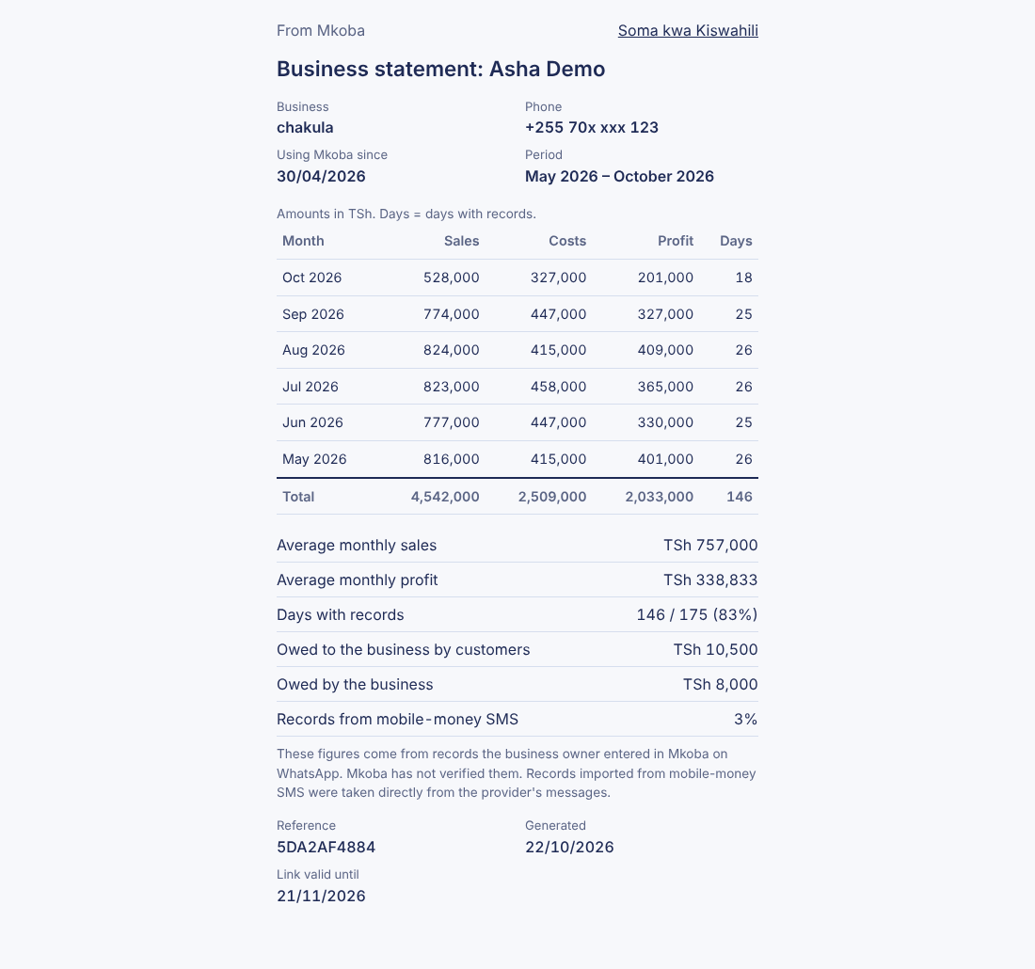
The statement shows your name, business, a partly hidden phone number, when you started using Mkoba, and a table of the last six months: sales, costs, profit and days with records. Under it are averages, debts and how many records came from mobile-money SMS. The note at the bottom says these are your own records, not checked by Mkoba. Details are in chapter 10.

3.4 The privacy page
A plain page explaining what Mkoba stores, why, who sees it, how long it is kept and your choices. It has a Swahili version (/faragha) and an English version (/privacy), linked to each other at the top. Details are in 11.3.

3.5 The admin page
For the administrator only. Described in chapter 15.

4. Recording sales, purchases and expenses
This is the main job of Mkoba. You write what happened in your own words, and Mkoba saves it as one of three kinds of record:
Kind | Swahili | Meaning | Counts as
Sale | mauzo | Money that came in from selling | Money in
Purchase | manunuzi | Stock you bought to sell or to cook with | Money out
Expense | matumizi | Running costs: rent, electricity, transport, wages | Money out
Before you start: you must have replied NAKUBALI to the consent message (chapter 2). Until you do, Mkoba saves nothing.

4.1 Record one sale
- Open the Mkoba chat in WhatsApp.
- Type the word for what you did, what you sold, and the money. Example: nimeuza chips 5000
- Press send.
- Wait for the reply. It will be: Sawa! Nimeongeza mauzo ya chips TSh 5,000. Asante!
The word Sawa! means it is saved. Nothing else is needed.

4.2 Record a purchase or an expense
The steps are the same; only the first word changes.
- Purchase: nimenunua mchele kilo 10 kwa 25,000 → saved as manunuzi of mchele, 10 kg, TSh 25,000.
- Expense: nimelipa umeme 15k → saved as matumizi of umeme, TSh 15,000.

4.3 The words Mkoba recognises
Mkoba decides the kind of record from the action word. You can use any of these forms (and short typing mistakes such as nmeuza or nimenunu are usually corrected for you):
Kind | Swahili words | English words
Sale | nimeuza, niliuza, tumeuza, tuliuza, nimeuzia, nauza, mauzo, nimepokea, nimepata, nimelipwa, nimetumiwa | sold, sale, sales, sell
Purchase | nimenunua, nilinunua, tumenunua, nanunua, manunuzi, ununuzi, nimeuziwa | bought, buy, purchase, purchased
Expense | nimelipa, nililipa, tumelipa, nimetumia, nilitumia, gharama, matumizi | paid, spent, expense, expenses
Important: nimelipwa (I was paid) and nimetumiwa (I was sent money) are saved as sales, because money came in. nimeuziwa (I was sold) is saved as a purchase.

4.4 How to write the amount
All of these mean TSh 5,000:
- Digits: 5000, 5,000, 5.000
- With a currency word: Tsh 5000, 5000/=, sh 5000
- Thousands with k: 5k. Millions with m: 2m = TSh 2,000,000
- Swahili words: elfu tano. Other examples: elfu kumi na tano = 15,000, elfu mbili mia tano = 2,500, mia saba hamsini = 750
- Street words: buku tano, ngiri tano, thao tano (buku, ngiri and thao each mean 1,000); jero mbili = 1,000 (jero means 500)
Mkoba works only in Tanzanian shillings. There is no other currency.

4.5 Quantities and units
You can add how much you bought or sold. Mkoba keeps it next to the record; it is not added to the money.
- Kilograms: kilo 10, 10 kg, 10kg
- Litres: lita 5, 5 l
- Grams: gramu 500
- Pieces: vipande 3, 3 pcs
Example: nimenunua mafuta lita 5 kwa 20000 is saved as a purchase of mafuta (5 l), TSh 20,000.

4.6 Several records in one message
You can send many records at once, either one per line or one after another.
nimeuza chips 5000
nimenunua mafuta 3000
or on one line: nimeuza chips 5000 nimenunua mafuta 3000
Mkoba splits the message at each action word and replies with a list:
Sawa! Nimeongeza:
- Mauzo ya chips TSh 5,000
- Manunuzi ya mafuta TSh 3,000
Asante!
If any one part is not understood, nothing from that message is saved, and Mkoba tells you which part to fix. Send the whole message again, corrected.

4.7 Price memory: selling by count
When you write a small number (below 100) without the word Tsh, Mkoba treats it as a count of items, not money, because nothing sells for less than TSh 100.
If you have sold this item before, Mkoba uses your last price for it, works out the total, and asks you to confirm:
- You have earlier saved nimeuza soda 3 kwa 1800 (TSh 600 each).
- Now you send nimeuza soda 10.
- Mkoba replies with what it understood, the line (soda: TSh 600 kila moja, kama rekodi yako ya mwisho) and Ni sahihi? Jibu NDIO au HAPANA.
- Reply NDIO to save TSh 6,000, or HAPANA to cancel (see chapter 5).
If Mkoba has no earlier price for the item, it asks:
maandazi 5 kwa bei gani? Andika kwa mfano: nimeuza maandazi 5 kwa 3000
Send the message again with the total money, as shown.
Price memory works for sales and purchases, using only your own confirmed records.

4.8 When Mkoba is unsure
Mkoba scores how sure it is about each message:
- Sure: saved at once; reply starts with Sawa!
- Fairly sure: not counted yet; Mkoba shows what it understood and asks NDIO or HAPANA (chapter 5). This happens, for example, with two plain numbers (nimeuza 3000 4000) or a price calculated from memory.
- Not sure: nothing saved; Mkoba replies Samahani, sikuelewa vizuri. Ulitumia/uliuza kiasi gani, TSh ngapi? Send the message again with an action word and an amount.
Common reasons for "not sure":
- No action word: chips 5000
- No amount: nimeuza chips

4.9 Messages Mkoba cannot read
Mkoba reads text only. If you send a voice note, photo, sticker, video, document or location, nothing is saved and Mkoba replies asking you to type the record instead.

4.10 Dates and times
Every record gets the date and time Mkoba received your message (Tanzania time). You cannot set a different date. Words like jana (yesterday) in a message are ignored, so record each day's business on that day.

5. Confirming, correcting and deleting records

5.1 Answering a YES/NO question
When Mkoba is fairly sure but not certain, it shows what it understood and waits:
Nimeelewa hivi:
- Mauzo ya soda (10) TSh 6,000
(soda: TSh 600 kila moja, kama rekodi yako ya mwisho)
Ni sahihi? Jibu NDIO au HAPANA.
The record is not counted in any summary until you answer.
To save it:
- Reply with one of: NDIO, ndiyo, sawa, ok, sahihi, yes, y.
- Mkoba replies Sawa! Nimeongeza ... and the record now counts.
To cancel it:
- Reply with one of: HAPANA, sio, si sahihi, no, n.
- Mkoba replies: Sawa, sijahifadhi. Tafadhali tuma tena kwa usahihi, mfano: nimenunua mchele 25000
- Send the record again, written more clearly.
Rules to know:
- The question stays open for 1 hour. After that, NDIO no longer saves it; send the record again.
- If you send a new record instead of answering, the unanswered one is dropped and only the new one is handled.
- Your answer must be the only thing in the message. ndio nimeuza 5000 is not read as an answer.

5.2 Delete your last record (futa)
Use this when you saved something by mistake.
- Send futa (also accepted: futa ya mwisho, futa hiyo, ondoa, undo, delete).
- Mkoba deletes the last saved message's records and replies, for example: Nimefuta mauzo ya chips TSh 5,000.
Things to know:
- If your last message had several records, futa deletes all of them and lists them.
- Send futa again to delete the message before that, one message at a time.
- It also works for the last debt record (chapter 7).
- Only saved records are affected. A record waiting for NDIO/HAPANA is cancelled with HAPANA, not futa.
- If there is nothing to delete, Mkoba replies Hakuna rekodi ya kubadilisha.
- A deleted record cannot be brought back. Record it again if needed.

5.3 Change the amount of your last record (rekebisha)
Use this when the kind and item were right but the money was wrong.
- Send rekebisha followed by the correct amount, for example rekebisha 6500 (also accepted: badilisha, sahihisha, correct, edit). Any amount format from 4.4 works, such as rekebisha elfu sita.
- Mkoba replies, for example: Nimerekebisha mauzo ya chips: TSh 6,000 → TSh 6,500.
Things to know:
- Only the amount changes. To change the kind (sale/purchase/expense) or the item, use futa and send the record again.
- If you forget the amount, Mkoba replies Andika kiasi kipya, mfano: rekebisha 6000.
- If your last message had several records, rekebisha cannot choose one. Mkoba replies Ujumbe wako wa mwisho ulikuwa na rekodi 2. Andika "futa" kisha utume tena kwa usahihi. Follow that advice.
- Only the most recent message can be corrected. Older records cannot be edited.

6. Summaries and evening reports

6.1 Ask for a summary
- Send one of the words in the table. The word must be the whole message.
- Mkoba replies with the totals for that period.
Send | Period | Also accepted
leo | Today (from midnight) | today, muhtasari, ripoti, ripoti ya leo, hesabu ya leo
jana | Yesterday | yesterday, ripoti ya jana
wiki | This week, from Monday | wiki hii, week, this week, ripoti ya wiki
mwezi | This month, from the 1st | mwezi huu, month, this month, ripoti ya mwezi
salio | Everything since you started | balance, jumla, total
All periods use Tanzania time.

6.2 Reading a summary
Example reply to leo:
📊 Muhtasari wa leo:
Mauzo: TSh 38,000 (5)
Manunuzi: TSh 20,000 (2)
Matumizi: TSh 3,000 (1)
Faida: TSh 15,000
Inayouza zaidi: chips (TSh 25,000)
Gharama kubwa zaidi: mchele (TSh 20,000)
Jana: faida TSh 9,000
- The number in brackets after each total is how many records it adds up.
- Faida (profit) = Mauzo − Manunuzi − Matumizi. If the result is below zero, the line says Hasara (loss) with the amount.
- Inayouza zaidi: the item with the most sales money in the period.
- Gharama kubwa zaidi: the item with the most purchase and expense money in the period.
- Last line: the result of the period before (Jana for leo, Juzi for jana, Wiki iliyopita for wiki, Mwezi uliopita for mwezi), so you can compare.
The extra lines appear only when there is something to show: items need a name in your records, and the comparison needs records in the earlier period. salio shows totals only.
Only confirmed sales, purchases and expenses count. Debts (chapter 7) and records waiting for NDIO are not in these totals.
If there is nothing in the period, Mkoba replies Hakuna rekodi za leo bado. (or the period you asked).

6.3 The evening report
Every evening at 21:00 Tanzania time (saa 3 usiku), Mkoba sends you a summary automatically, if all of these are true:
- You agreed to the data terms (NAKUBALI).
- Evening reports are on for you (they are on unless you turned them off).
- You recorded something in the period.
Monday to Saturday the report covers today. On Sunday it covers the whole week, and also lists up to five people who owe you, with how many days the debt has been open.
What the report looks like depends on when you last wrote to Mkoba:
- You wrote within the last 23 hours: the full summary from 6.2, starting Habari Asha! and ending Kusitisha ripoti hizi, andika ACHA RIPOTI. It is in your chosen language.
- You have not written for 23 hours or more: WhatsApp rules allow only an approved message format. You get a shorter Swahili report with your name, the period, sales, purchases, expenses and profit or loss, without the extra lines.
You get at most one report per evening.

6.4 Turn evening reports off or on
To stop them:
- Send ACHA RIPOTI (also: sitisha ripoti, zima ripoti, stop reports).
- Mkoba replies: Sawa, nimesitisha ripoti za jioni. Kuwasha tena, andika ANZA RIPOTI.
To start them again:
- Send ANZA RIPOTI (also: washa ripoti, start reports).
- Mkoba replies: Sawa! Utapokea muhtasari kila jioni saa 3 usiku.
You cannot change the time of the report.

7. Debts (madeni)
Mkoba keeps a running balance with each person: what customers owe you (credit you gave) and what you owe suppliers. Debts are kept separate from sales and costs, so they never change your profit.

7.1 The four debt messages
What happened | Write it like this | Mkoba's reply
A customer took goods on credit (they owe you) | namdai Juma 5000, Juma anadaiwa 5000, nimemkopesha Juma 5000, Juma amekopa 5000 | Sawa! Juma anadaiwa TSh 5,000. then the balance
You took goods or money on credit (you owe them) | Juma ananidai 5000, nadaiwa na Juma 5000, nimekopa kwa Juma 5000 | Sawa! Unadaiwa na Juma TSh 5,000. then the balance
They paid you back | Juma amelipa 2000, Juma amenilipa 2000, Juma amerudisha 2000 | Sawa! Juma amelipa TSh 2,000. then the balance
You paid them back | nimemlipa Juma 2000, nimelipa deni la Juma 2000, nimemrudishia Juma 2000 | Sawa! Umemlipa Juma TSh 2,000. then the balance
English also works: lent Juma 5000, Juma owes me 5000, I owe Juma 5000, Juma paid 2000.
The second line of every reply is the new balance, for example Salio: Juma anadaiwa TSh 3,000. When the balance reaches zero it says Salio: Hakuna deni kati yako na Juma.

7.2 Step by step: a customer buys on credit, then pays
- Mama Neema takes food worth TSh 4,000 and will pay later. Send: Mama Neema anadaiwa 4000
- Mkoba replies: Sawa! Mama Neema anadaiwa TSh 4,000. and Salio: Mama Neema anadaiwa TSh 4,000.
- Two days later she pays TSh 1,500. Send: Mama Neema amelipa 1500
- Mkoba replies with the new balance: TSh 2,500.
Note: the food itself is not a sale until it is paid. If you also want the money in your sales totals, record the sale when she pays, for example nimeuza chakula 1500.

7.3 Names
- A name is one word (Juma), or one word after a title: mama, baba, bi, bw, bwana, kaka, dada, mzee, ndugu, shangazi, mjomba, mr, mrs (Mama Neema, Kaka Ali).
- Two-word names without a title do not work as expected: Juma Ali anadaiwa 4000 is saved under Ali only. Use one word or a title.
- Capital letters do not matter: juma and Juma are the same person.
- Use the same name every time for the same person, or Mkoba will treat them as two people.

7.4 Be careful with the word for paying
- nimemlipa Juma 2000 (I paid him) is a debt repayment.
- nimelipa Juma 2000 (without the m) is read as an ordinary expense called "juma".
If you forget the amount, Mkoba asks: Kiasi gani? Mfano: Juma amelipa 5000. Send the whole message again with the amount.

7.5 See your debts
Everyone: send madeni (or deni, debts). Example reply:
📒 Madeni:
Unaowadai:
- Juma TSh 3,000 (siku 12)
Wanaokudai:
- Mama Neema TSh 2,500 (siku 2)
- Unaowadai = people who owe you. Wanaokudai = people you owe.
- (siku 12) = days since the last new credit with that person.
- People with a zero balance are not listed. If nobody owes anything: Hakuna madeni.
One person: send deni Juma (also deni la Juma, debt Juma).
- If you owe them, or the balance is zero, you get one line.
- If they owe you, you get two messages. The first explains, the second is a ready reminder to forward:
Habari Juma, hii ni kumbukumbu ya deni lako kwa Asha: TSh 3,000 (tangu 10/10/2026). Asante!

7.6 Send a debt reminder to a customer
- Send deni Juma.
- Press and hold the second message (the one starting Habari Juma).
- Tap Sambaza (Forward).
- Choose Juma's chat in your WhatsApp contacts and send.
Mkoba never messages your customers itself; you decide whether to forward. The reminder shows your name only if you gave Mkoba a name during sign-up.

7.7 Fix a debt mistake
If the debt record was your last record, send futa to delete it (5.2) or rekebisha 4000 to change the amount (5.3). Otherwise, record the opposite entry to balance it out.

8. Mobile-money SMS
Instead of typing a payment, you can copy the confirmation SMS your mobile-money provider sent you and paste it into the Mkoba chat. Mkoba reads the amount, who was paid and the fee.
What is supported today: money leaving your Airtel Money Tanzania account (paying a till or Lipa number, paying a merchant, buying a bundle, sending money to a person). Money you receive is not read yet, and other providers (M-Pesa, Tigo Pesa, HaloPesa and others) are not supported. For those, type the record as in chapter 4.

8.1 Paste an SMS
- Open your phone's Messages app and find the Airtel Money confirmation SMS.
- Press and hold the message, then choose Copy.
- Open the Mkoba chat in WhatsApp.
- Press and hold the typing box, choose Paste, and send. Do not change the text.
- Read Mkoba's reply and answer it, as described below.

8.2 Paying a till, merchant or bundle
Mkoba shows what it will save and asks you to confirm:
Nimeelewa hivi:
- Manunuzi ya Duka La Mfano TSh 10,000
- Matumizi ya ada Airtel Money TSh 1,000
Ni sahihi? Jibu NDIO au HAPANA.
- Till, Lipa and merchant payments are saved as purchases (manunuzi).
- Bundle payments are saved as expenses (matumizi).
- The provider's fee, if the SMS shows one, is a separate expense called "ada Airtel Money".
Reply NDIO to save or HAPANA to cancel, within 1 hour (see 5.1).

8.3 Sending money to a person
Mkoba cannot know why you sent money to a person, so it asks:
Umetuma TSh 1,000 kwa Mfano Jina (ada TSh 45). Hii ni nini?
1 - Manunuzi (bidhaa za biashara)
2 - Matumizi ya biashara
3 - Si ya biashara (binafsi)
Jibu 1, 2 au 3.
- Reply 1 if it paid for stock, 2 if it was a business cost, or 3 if it was personal (family, yourself).
- For 1 or 2, Mkoba replies Sawa! Nimeongeza: ... with the amount and the fee (the fee is always an expense).
- For 3, Mkoba replies Sawa, sijauweka kwenye hesabu za biashara. and nothing is saved.
You can also reply with the words manunuzi, matumizi or binafsi. If you reply NDIO, Mkoba asks again for 1, 2 or 3. The question stays open for 1 hour.

8.4 Messages Mkoba recognises but does not save
SMS type | Mkoba replies (meaning)
Cash deposit at an agent, or moving money to your Airtel Money Global Pay card | It is your own money moving, not a sale or cost. Not saved.
A bank-card payment message | It is a bank card, not mobile money. Not saved.
An M-Pesa Kenya message in Ksh | Mkoba works in TSh only. Not saved.

8.5 Pasting the same SMS twice
Each Airtel SMS has a transaction number (TID). If you paste an SMS that is already saved, Mkoba replies Muamala huu (TID...) tayari umeshawekwa kwenye hesabu. and saves nothing again.

8.6 If Mkoba does not recognise the SMS
The text is then read like a normal typed message. Usually Mkoba replies Samahani, sikuelewa vizuri..., but if the SMS contains a word such as "paid" and a number, it may be misread as an ordinary record. Always read the reply: if it is wrong, answer HAPANA (if asked) or send futa (if saved), then type the record yourself, for example nimenunua mafuta 10000.

9. The web dashboard
The dashboard shows your numbers on a web page: profit for today, this week or this month, a 14-day chart, your latest records and your debts. It only displays information; all changes are made in WhatsApp. The dashboard is in Swahili only.

9.1 Open the dashboard for the first time
- In the Mkoba chat, send dashibodi (also: dashboard, mtandaoni, link ya dashibodi).
- Mkoba replies: Fungua dashibodi yako hapa (kiungo kinafanya kazi kwa dakika 15, mara moja tu): followed by a link starting https://mkoba.digital/d/login?t=.
- Tap the link. Your phone's browser opens this page:
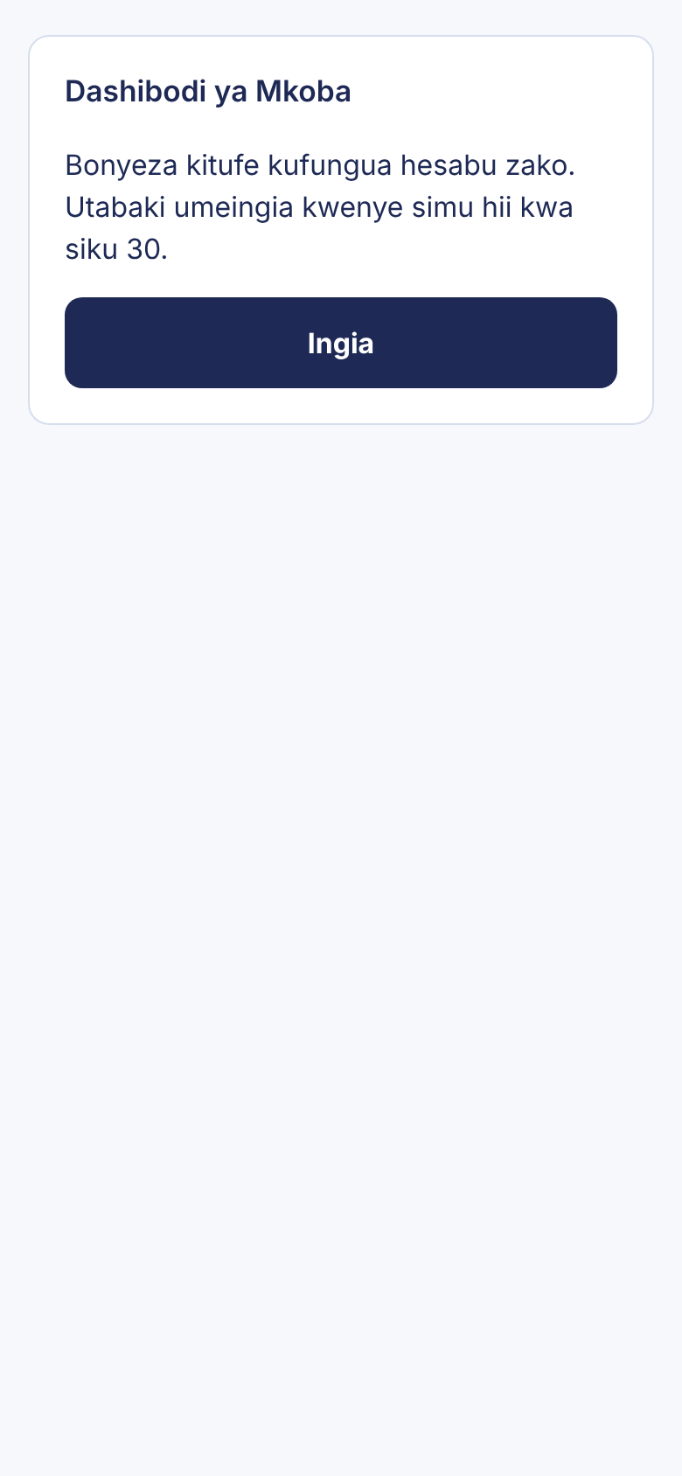
- Tap the green Ingia (Log in) button.
- Your dashboard opens (see 3.2 for every part of the page).
Rules for the link:
- It works for 15 minutes and one time only.
- Opening the link does not log you in by itself; you must tap Ingia. This stops link-preview tools from using it up.
- Do not forward the link: whoever taps Ingia first sees your records.

9.2 Stay logged in
After you tap Ingia, the browser on that phone stays logged in for 30 days. To come back, open the same browser and go to https://mkoba.digital/d. You do not need a new link until the 30 days are over or you log out.
If you are not logged in, the page looks like this. Send dashibodi in WhatsApp to get a new link.
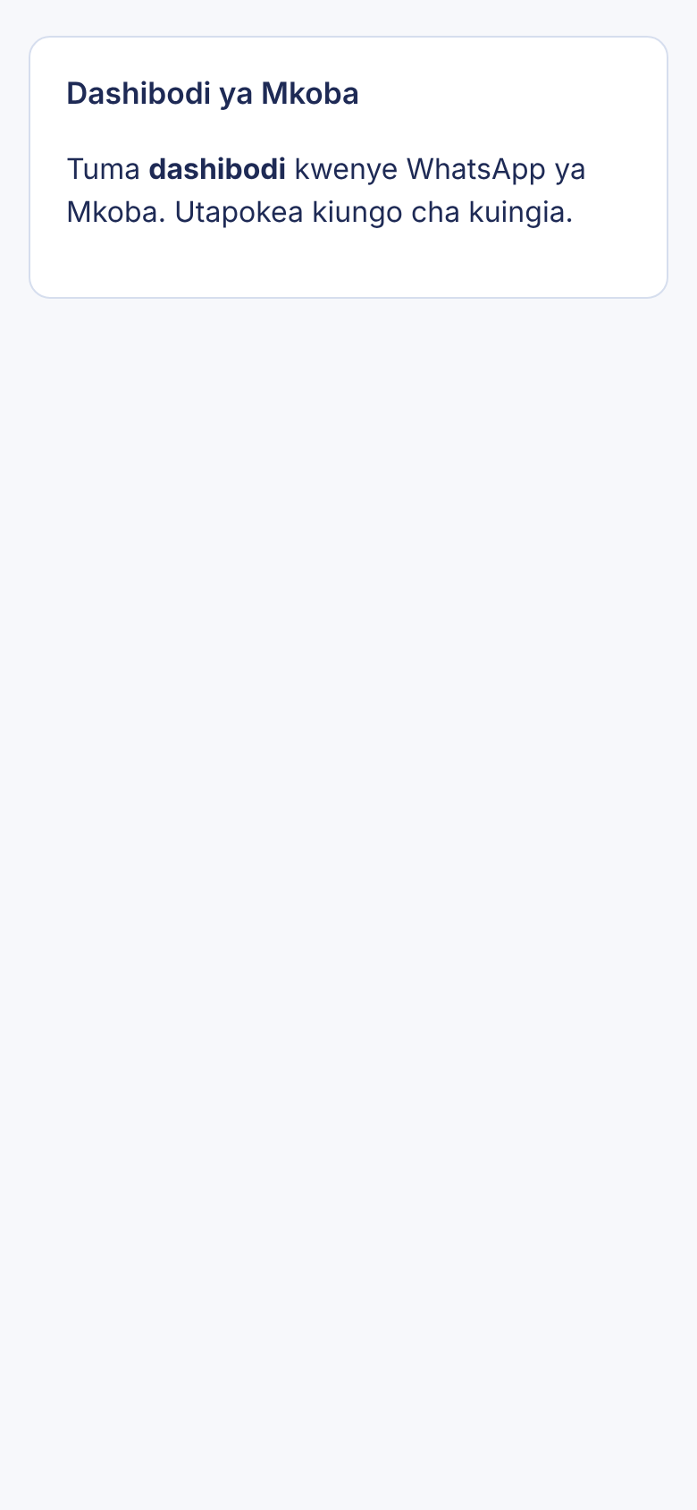

9.3 Change the period
Tap Leo (today), Wiki hii (this week, from Monday) or Mwezi huu (this month). The big number and the breakdown change to that period. The 14-day chart, recent records and debts stay the same.
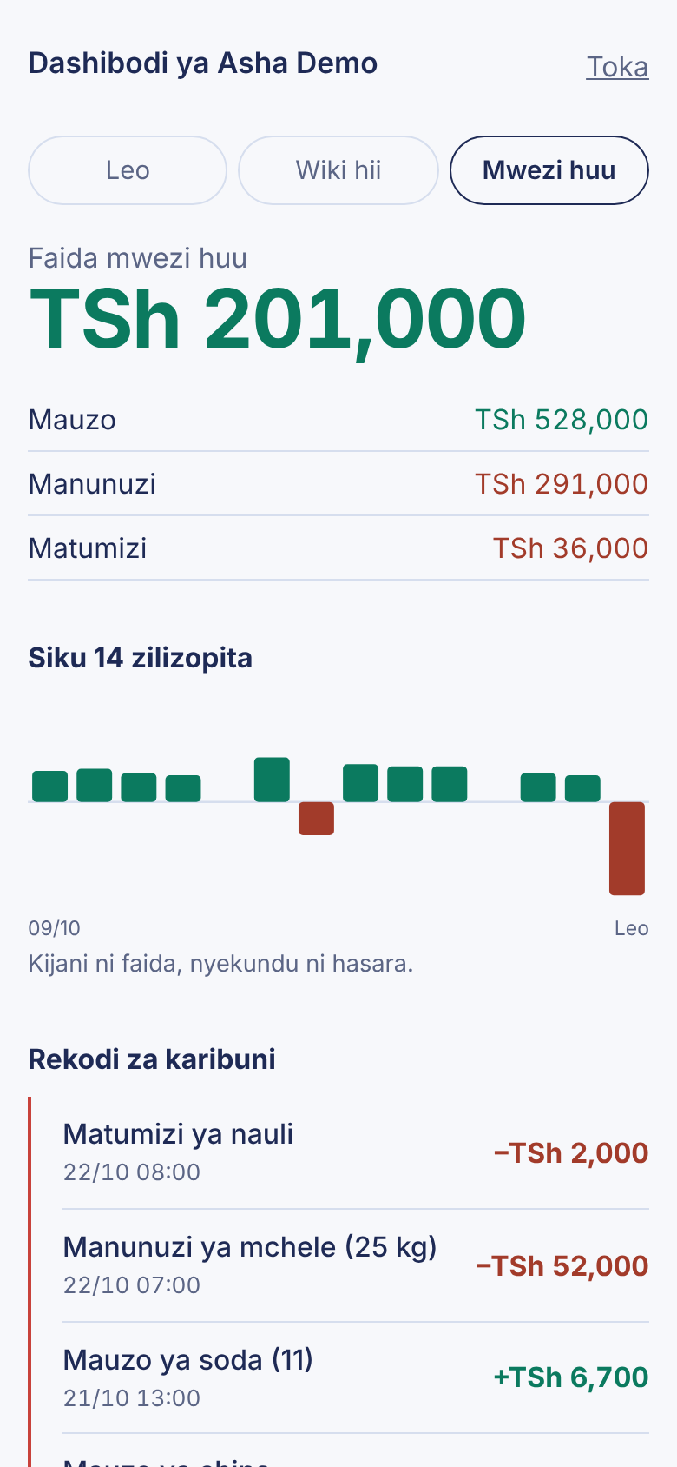

9.4 Log out
Do this on a shared or borrowed phone.
- Tap Toka at the top right of the dashboard.
- The page shows Umetoka (You have logged out).
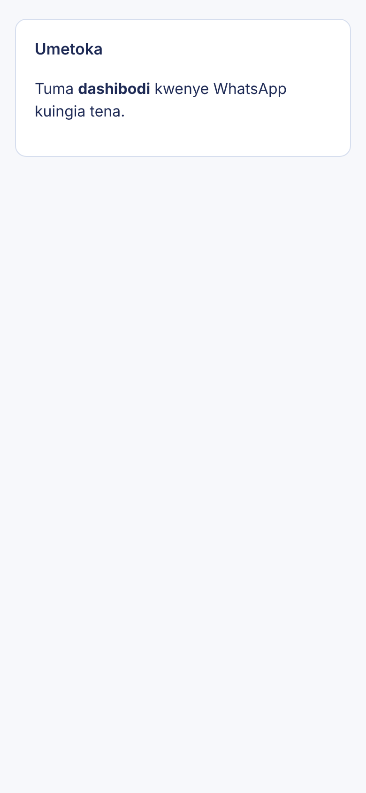

9.5 When the link does not work
If the link is older than 15 minutes or was already used, you see:
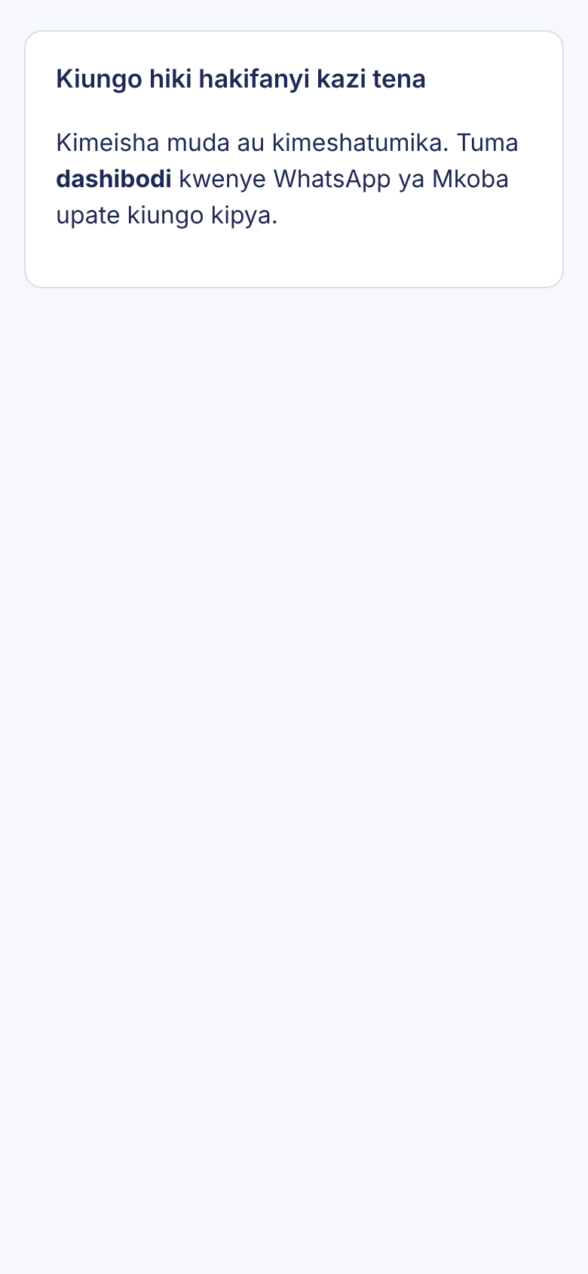
Send dashibodi again in WhatsApp and use the new link straight away.

9.6 What the dashboard counts
The same rules as WhatsApp summaries (6.2): only confirmed sales, purchases and expenses count towards profit. Records waiting for NDIO are not shown. Debt records appear in Rekodi za karibuni without a + or − sign, because they are not sales or costs.

10. The business statement for lenders
A lender, bank or SACCO usually wants to see how your business has done before giving a loan. Mkoba can make a web page with your last six months of figures and give you a private link to share.

10.1 Create a statement
- In the Mkoba chat, send taarifa ya biashara (also: ripoti ya biashara, taarifa ya mkopo, ripoti ya mkopo, statement, business statement, loan statement).
- Mkoba replies:
Taarifa yako ya biashara iko tayari (miezi 6 iliyopita). Unaweza kumtumia mkopeshaji au SACCO kiungo hiki; kinafanya kazi siku 30:
https://mkoba.digital/s/...
Kukifunga mapema, andika FUNGA TAARIFA.
- Tap the link to check the page yourself before sharing it.

10.2 Share it with a lender
Choose one way:
- WhatsApp: press and hold Mkoba's message with the link, tap Sambaza (Forward), and choose the lender's chat. Or copy only the link and paste it into a message.
- Email or SMS: press and hold the link, choose Copy, and paste it into your email or SMS to the lender.
- On paper: open the link on a computer and use the browser's Print command (Ctrl+P on Windows, Cmd+P on Mac). Choose a printer, or "Save as PDF" to get a file.
The lender does not need WhatsApp or a Mkoba account to open the link.

10.3 What the lender sees
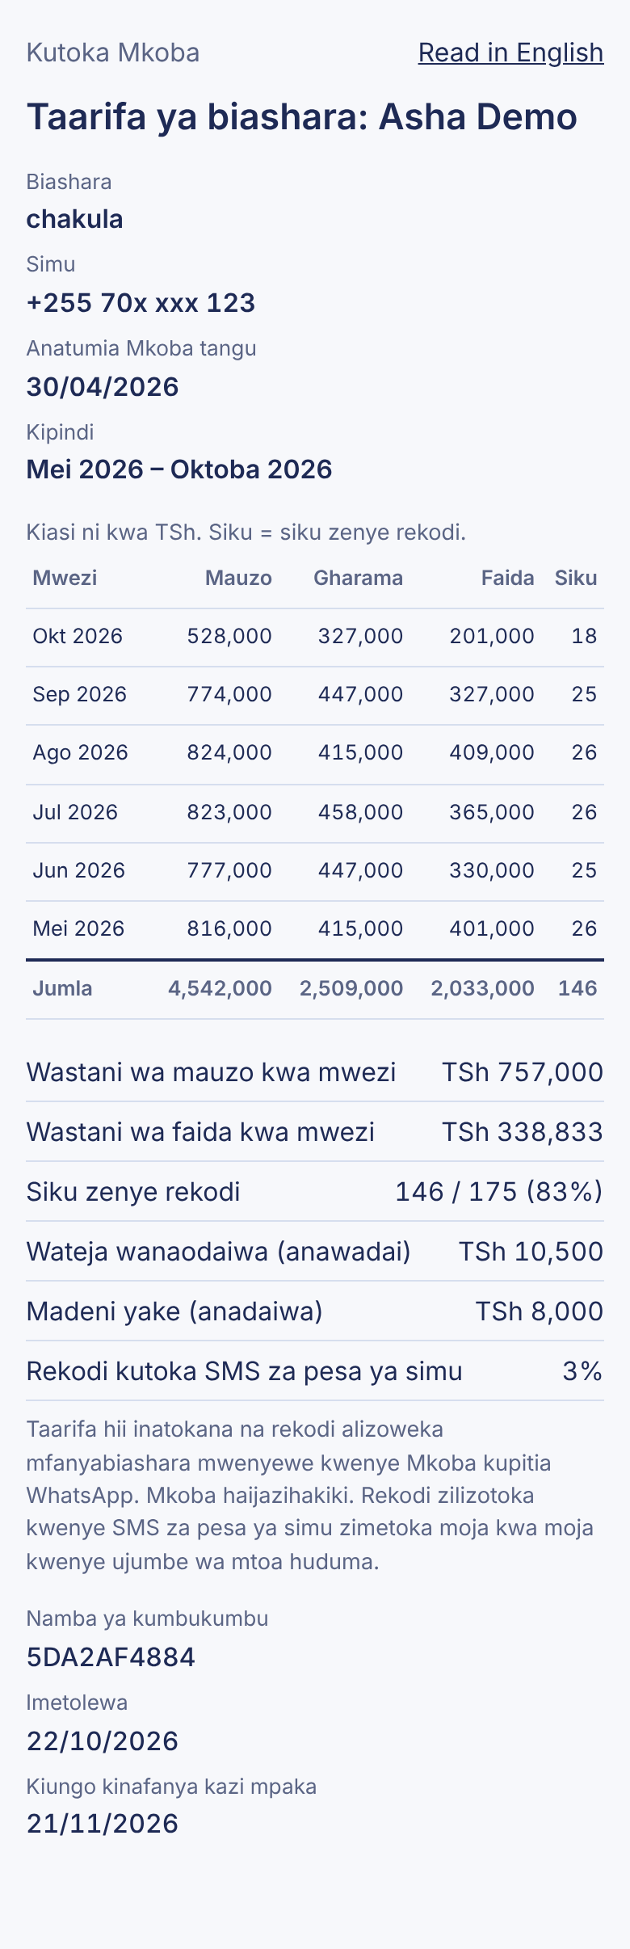
The page shows, from top to bottom:
- Title with your name (if you gave one during sign-up), and a link to switch language: Read in English / Soma kwa Kiswahili. It opens in your chosen language.
- Biashara (business type, if you gave one), Simu (your phone number with the middle digits hidden), Anatumia Mkoba tangu (date of your first record) and Kipindi (the six months covered).
- The table: one row per month, newest first, with Mauzo (sales), Gharama (purchases plus expenses), Faida (profit; a loss has a minus sign and is red) and Siku (number of days with records). Amounts are in TSh. The last row is the total.
- Averages and other facts: average monthly sales and profit (counted over months that have records), days with records out of all days in the period, how much customers owe you, how much you owe, and the share of records that came from mobile-money SMS.
- A note saying that the figures are the owner's own records and that Mkoba has not verified them.
- Namba ya kumbukumbu (reference number), the date it was generated, and the date the link stops working.
The statement shows totals only. Individual records, customer names and your messages are never shown.

10.4 How long the link works, and closing it
- A link works for 30 days, then shows a "closed" page.
- Making a new statement closes all your older statement links. Only the newest link works.
- To close all your links early (for example after the loan decision), send FUNGA TAARIFA (also: funga taarifa ya biashara, close statement, revoke statement). Mkoba replies: Sawa, viungo vyote vya taarifa yako ya biashara vimefungwa.
A closed or expired link shows this page:
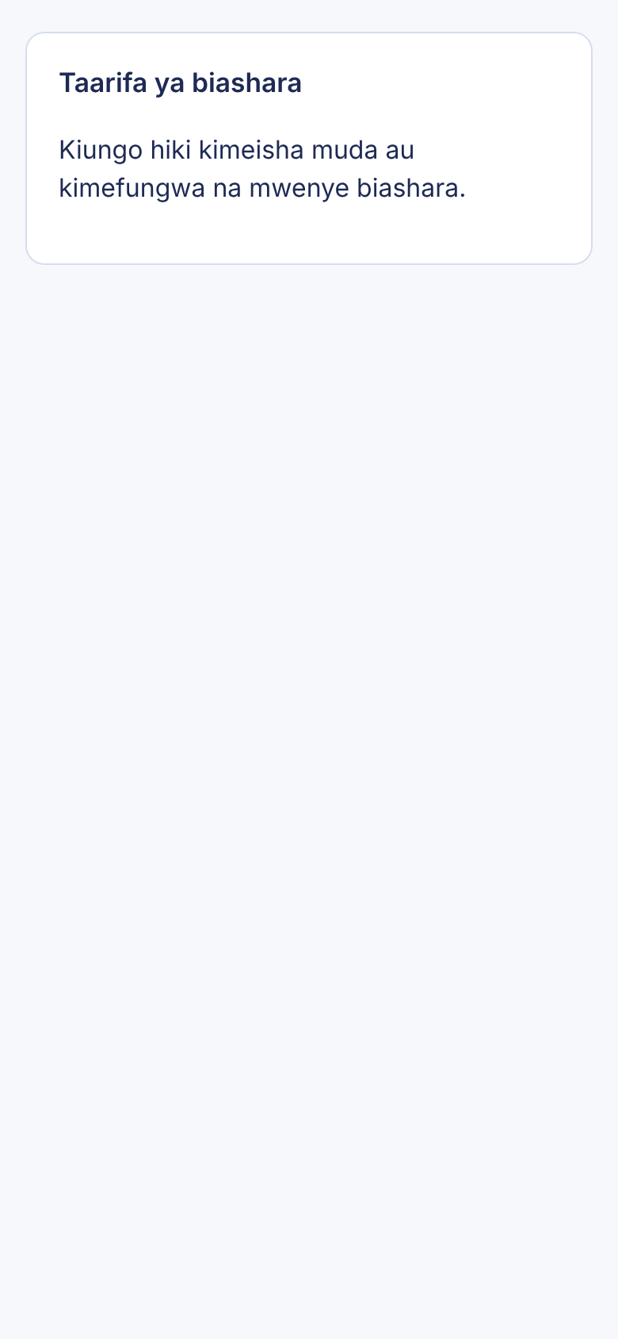

10.5 Make your statement stronger
Lenders look for regular, complete records. Record every day, record costs as well as sales, and correct mistakes straight away (chapter 5). Months before you started using Mkoba show zeros.

11. Language, privacy and your data

11.1 Choose your language
Mkoba replies in Swahili or English. Swahili is the default.
Switch on purpose:
- Send english (also kiingereza, in english). Mkoba replies: OK, I'll reply in English. For Swahili, send KISWAHILI.
- To go back, send kiswahili (also swahili, kwa kiswahili). Mkoba replies: Sawa, nitajibu kwa Kiswahili. Kwa Kiingereza, tuma ENGLISH.
Automatic switch: if a message is clearly written in only one language (for example sold chips 5000), Mkoba switches to that language and remembers it. Mixed messages do not change the language. Pasted mobile-money SMS never change it.
What follows your language: all WhatsApp replies, the full evening report, the privacy link and the language the statement opens in. What is always Swahili: the web dashboard and the short evening report sent after 23 hours of silence (6.3).

11.2 Agreeing to the data terms
Your first message to Mkoba gets a welcome that explains what Mkoba stores, with a link to the privacy page, and ends Jibu NAKUBALI kuendelea.
- Reply NAKUBALI (also ninakubali, kubali, ndio, ndiyo, I agree, agree, accept, yes).
- Until you agree, Mkoba records nothing, sends no evening reports, and answers every message with a reminder to agree.
- FUTA DATA works even before you agree.

11.3 The privacy page
Open https://mkoba.digital/faragha (Swahili) or https://mkoba.digital/privacy (English). Each has a link to the other at the top.
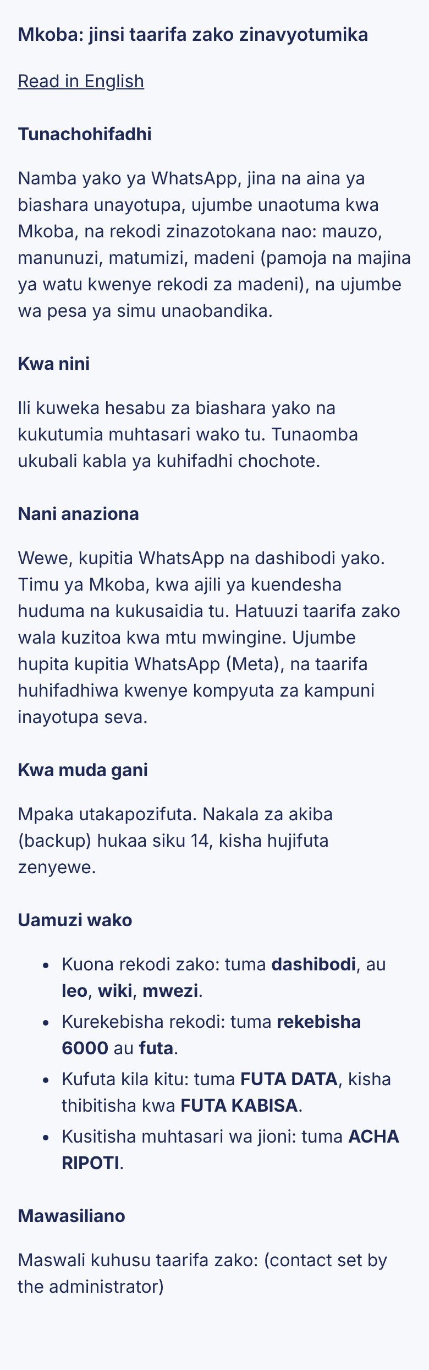
It explains:
- What is stored: your WhatsApp number, the name and business type you give, your messages to Mkoba, and the records made from them, including names of people in your debt records and pasted mobile-money messages.
- Why: only to keep your records and send your summaries.
- Who sees it: you; the Mkoba team only to run and support the service. Data is not sold or shared. Messages pass through WhatsApp (Meta), and data is stored on the server provider's computers.
- How long: until you delete it. Backup copies are kept 14 days, then deleted automatically.
- Your choices: see, fix and delete your records, and stop evening reports.
The page shows a contact line and the data location only when the administrator has set them (15.3).

11.4 Delete all your data
This removes everything about you from Mkoba: your name, all records, debts, messages, dashboard logins and statement links. It cannot be undone.
- Send FUTA DATA (also futa taarifa, futa taarifa zangu, futa data zangu, futa akaunti, futa akaunti yangu, delete my data, delete account).
- Mkoba warns: Hii itafuta KABISA jina lako, rekodi zako zote, madeni na ujumbe wako wote kwenye Mkoba. Haiwezi kurudishwa. Kuthibitisha, andika FUTA KABISA ndani ya dakika 10.
- If you are sure, send FUTA KABISA (English: DELETE EVERYTHING) within 10 minutes.
- Mkoba replies: Taarifa zako zote zimefutwa. Nakala za akiba (backup) hujifuta zenyewe ndani ya siku 14. Ukituma ujumbe tena, utaanza upya.
If you change your mind, just do not send step 3; nothing happens. If you send FUTA KABISA without step 1, or after 10 minutes, Mkoba replies Hakuna ombi la kufuta linalosubiri... and deletes nothing.
After deletion, any message you send starts Mkoba from the beginning, as a new user. Your WhatsApp chat history on your own phone is not affected; delete it in WhatsApp if you wish.
Not the same as futa: futa alone deletes only your last record (5.2).

12. Everyday workflows
These combine the features above into complete routines. Each step names the chapter with more detail.

12.1 A normal business day
- Morning, buying stock: after paying, send for example nimenunua viazi kilo 20 kwa 30000 and nimelipa nauli 2000. Check each reply starts with Sawa! (4.2).
- During the day, selling: send sales as they happen, or in groups: nimeuza chips 12000, nimeuza soda 10 (price memory asks to confirm; reply NDIO) (4.1, 4.7).
- Credit sales: Mama Neema anadaiwa 3000 (7.1).
- Mistake? Send futa or rekebisha 6500 immediately after (chapter 5).
- Evening: at 21:00 the evening report arrives. Or send leo any time to see today's result (chapter 6).

12.2 End of the week
- On Sunday evening the report covers the whole week and lists customers who owe you.
- Send madeni to see all debts with their age (7.5).
- For each customer who owes you, send deni <name> and forward the reminder (7.6).
- Send wiki or open the dashboard with dashibodi to see the week's profit and the 14-day chart (chapter 9).

12.3 Applying for a loan
- Make sure your records for the last months are complete and correct.
- Send taarifa ya biashara and open the link to check it (10.1).
- Share the link with the lender (10.2), or print it to PDF.
- After the decision, send FUNGA TAARIFA to close the link (10.4).

12.4 Paying a supplier with Airtel Money
- Pay the supplier with Airtel Money as usual.
- Copy the confirmation SMS and paste it into the Mkoba chat (8.1).
- If it was a till or merchant payment, reply NDIO. If it went to a person, reply 1 for stock, 2 for a business cost or 3 if personal (8.2, 8.3).

12.5 Using a new phone or new WhatsApp number
- Same WhatsApp number on a new phone: nothing to do. Your records are on Mkoba's server, not on the phone. Send dashibodi again to log in to the dashboard on the new phone.
- New WhatsApp number: Mkoba knows you by your number, so a new number starts as a new user with no records. Records cannot be moved between numbers in the current version.

13. Managing your records over time

13.1 Where your records are
Your records are stored on Mkoba's server, linked to your WhatsApp number. They are not stored on your phone, so losing or changing your phone does not lose them (12.5). Deleting the WhatsApp chat on your phone also does not delete them; only FUTA DATA does (11.4).

13.2 Ways to look at your records
You want | Do this
Totals for today, yesterday, this week, this month or all time | Send leo, jana, wiki, mwezi or salio (chapter 6)
Your 12 most recent records with date and time | Open the dashboard, section Rekodi za karibuni (chapter 9)
Profit per day for the last 14 days | Dashboard chart (chapter 9)
Monthly totals for the last 6 months | Business statement (chapter 10)
Debts | Send madeni or deni <name> (7.5)
There is no full list of every record and no spreadsheet download in the current version.

13.3 What you can and cannot change
Change | Possible? | How
Amount of the last record | Yes | rekebisha <amount> (5.3)
Delete the last record, then the one before, and so on | Yes | futa, repeated (5.2)
Kind, item or quantity of a record | Only by deleting and re-sending | futa, then send again
A record from days ago, without deleting newer ones | No | Ask the administrator (chapter 20)
Date of a record | No | Records always get the time they were received (4.10)
Your name or business type after sign-up | No | Ask the administrator
Everything | Yes, delete all | FUTA DATA then FUTA KABISA (11.4)

13.4 Good habits
- Record each sale or cost the same day, ideally as it happens.
- Read every reply. Sawa! = saved; a question = not saved yet.
- Use the same item names (chips, not sometimes chipsi) so best-seller lines and price memory work.
- Use the same name for each debtor.
- Do not record money you move between your own accounts; it is not a sale or a cost.

14. Messages Mkoba sends you
The Swahili text of every kind of reply, what it means and what to do next. English replies say the same thing in English. Parts in angle brackets change with your message.
Mkoba says (starts with) | Meaning | What to do
Karibu Mkoba! 👋 ... Jibu NAKUBALI kuendelea. | Welcome and data terms | Read, then reply NAKUBALI (chapter 2, 11.2)
Kabla ya kuanza, tafadhali kubali masharti... | You have not agreed yet | Reply NAKUBALI
Asante! Kwanza, jina lako ni nani? | Asking your name | Send your name, or ruka to skip
Asante <name>! Unafanya biashara gani?... | Asking your business type | Send it (e.g. chakula), or ruka
Safi, <name>! Sasa uko tayari. + help list | Sign-up finished | Start recording
Sawa! Nimeongeza ... Asante! | Saved | Nothing
Nimeelewa hivi: ... Jibu NDIO au HAPANA. | Not saved yet, needs your check | NDIO or HAPANA within 1 hour (5.1)
<item> <n> kwa bei gani?... | Count without price, no earlier price | Send again with the total amount (4.7)
Samahani, sikuelewa vizuri... | Nothing saved | Send again with action word and amount (4.8)
Sawa, sijahifadhi... | You said HAPANA; nothing saved | Send it again correctly
Nimefuta ... | Last record deleted | Nothing
Nimerekebisha ...: <old> → <new>. | Amount changed | Nothing
Hakuna rekodi ya kubadilisha. | Nothing to delete or change | Nothing
Ujumbe wako wa mwisho ulikuwa na rekodi <n>... | rekebisha cannot pick one of several | futa, then send again (5.3)
📊 Muhtasari wa <period>: | Your summary | Read (6.2)
Hakuna rekodi za <period> bado. | Nothing recorded in that period | Nothing
Habari <name>! ... Kusitisha ripoti hizi, andika ACHA RIPOTI. | Evening report | Read, or ACHA RIPOTI to stop (6.4)
Sawa! <name> anadaiwa ... Salio: ... (and other debt forms) | Debt saved, new balance | Nothing (7.1)
Kiasi gani? Mfano: ... | Debt without amount | Send again with amount
📒 Madeni: | Debt list | Read (7.5)
Unaweza kumtumia <name> ujumbe unaofuata... + reminder | Ready reminder | Forward the second message (7.6)
Umetuma TSh ... Hii ni nini? ... Jibu 1, 2 au 3. | Money sent to a person | 1, 2 or 3 (8.3)
Muamala huu (...) tayari umeshawekwa kwenye hesabu. | SMS already recorded | Nothing (8.5)
Huu ni uhamisho wa pesa zako mwenyewe... / ...kadi ya benki... / ...kwa TSh tu... | SMS recognised, not saved | Nothing (8.4)
Fungua dashibodi yako hapa... | Dashboard link | Open within 15 minutes, tap Ingia (9.1)
Taarifa yako ya biashara iko tayari... | Statement link | Check, then share (10.1)
Sawa, viungo vyote vya taarifa yako ya biashara vimefungwa. | Statement links closed | Nothing
Sawa, nitajibu kwa Kiswahili... / OK, I'll reply in English... | Language changed | Nothing (11.1)
Hii itafuta KABISA ... | Deletion warning | FUTA KABISA within 10 minutes, or ignore (11.4)
Taarifa zako zote zimefutwa... | All data deleted | Nothing
Samahani, bado siwezi kusikiliza ujumbe wa sauti... | You sent a voice note | Type it instead (4.9)
Samahani, ninaelewa ujumbe wa maandishi tu... | You sent a photo, sticker, file, etc. | Type it instead
Samahani, kuna tatizo la mfumo... | Error on Mkoba's side | Wait a few minutes, send again (chapter 16)
Mkoba sends no reply to emoji reactions, and none when the same WhatsApp message is delivered to it twice.

15. Administrator guide
This chapter is for the person who runs Mkoba, not for vendors. It assumes access to the server and to the GitHub repository. No passwords, tokens or keys are written in this manual; they live only in the server's .env file.

15.1 The admin page
- Open https://mkoba.digital/admin in a browser.
- The browser asks for a user name and password. Enter user name admin and the password set as ADMIN_PASSWORD in .env.
- The admin page opens.
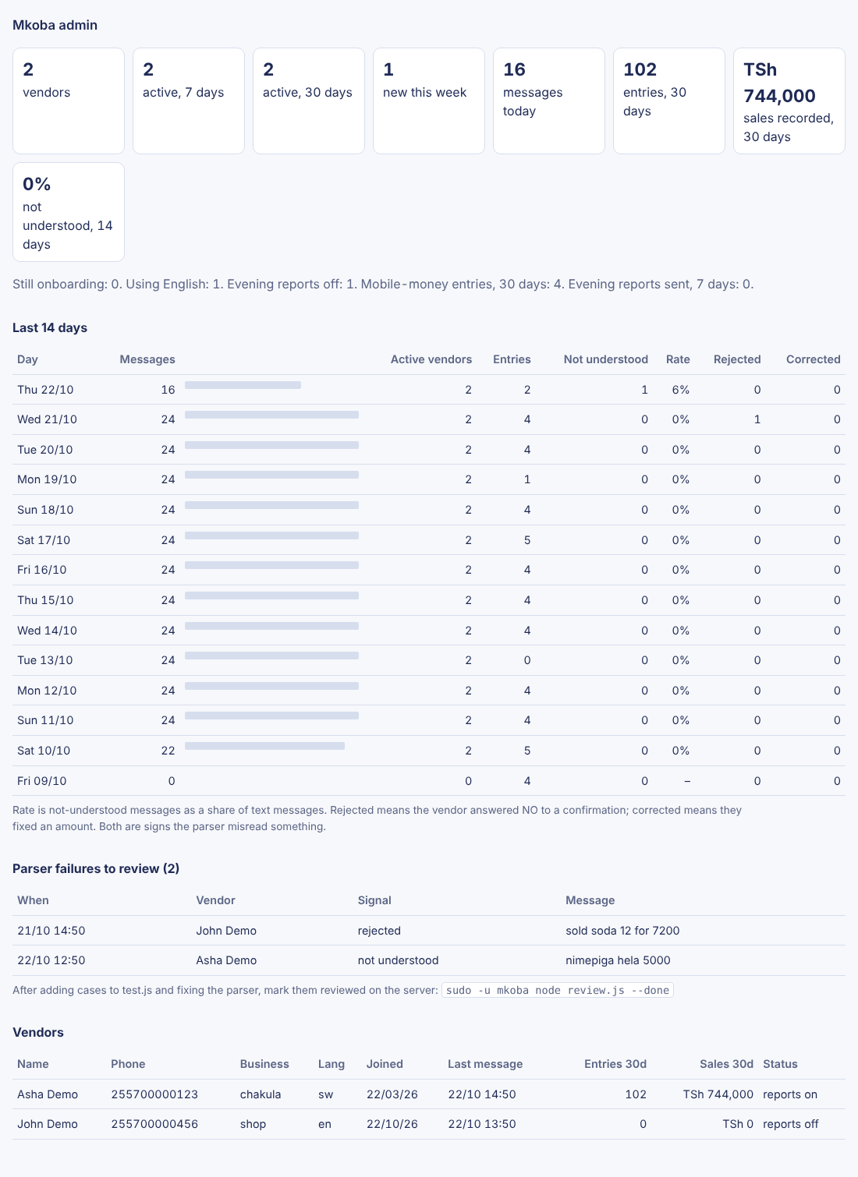
What it shows:
- Summary boxes: total vendors; active in the last 7 and 30 days; new in 7 days; vendors still in sign-up; English users; reports turned off; messages today; records, sales and mobile-money records in 30 days; evening reports sent in 7 days; parser failures not yet reviewed.
- Last 14 days: per day, messages, active vendors, records saved, and parser quality: not understood, rate, rejected (vendor said HAPANA) and corrected (vendor used rekebisha).
- Parser failures to review: messages Mkoba did not understand, or that vendors rejected or corrected.
- Vendors: name, phone, business, language, join date, last message, records and sales in 30 days, and status.
Security rules: if ADMIN_PASSWORD is not set, the page does not exist ("Not Found"). After 5 wrong passwords from one address within 15 minutes, that address is blocked for 15 minutes.

15.2 Reviewing parser failures
On the server, in the app folder:
- Run node review.js to list unreviewed failures, each with what the parser does with that text now.
- Add important cases to test.js, fix parser.js, and run node test.js until all tests pass.
- Deploy (15.5).
- Run node review.js --done to mark the listed failures as reviewed.

15.3 Settings (.env)
The file .env in the app folder holds the settings. .env.example in the repository lists them without values.
Setting | Purpose
DATABASE_URL, DATABASE_SSL | PostgreSQL connection
WHATSAPP_TOKEN, WHATSAPP_PHONE_NUMBER_ID | Sending WhatsApp messages (Meta Cloud API)
META_APP_SECRET | Checking that webhook calls really come from Meta
WEBHOOK_VERIFY_TOKEN | Meta's one-time webhook verification
PORT | Port the app listens on (3000 in production, behind nginx)
PUBLIC_URL | Base address used in links (default https://mkoba.digital)
ADMIN_PASSWORD | Admin page password; unset = admin page off
PRIVACY_CONTACT | Contact line on the privacy page; unset = no contact line
DATA_LOCATION, DATA_LOCATION_SW | Where data is stored, shown on the privacy page (English, Swahili)
REPORT_TEMPLATE, REPORT_TEMPLATE_LANG | Approved template for evening reports (default mkoba_muhtasari, sw)
LOG_LEVEL | Amount of logging
DRY_RUN | Testing only: no WhatsApp messages are really sent
After changing .env, reload the app (15.4).

15.4 Running the service
Part | What it is | Useful commands
App | PM2 process mkoba-app, 2 instances, folder /var/www/mkobalabs | pm2 status, pm2 logs mkoba-app, pm2 startOrReload ecosystem.config.js (reload without downtime)
Web server | nginx site mkoba, HTTPS certificate from Certbot, forwards to port 3000 | sudo nginx -t, sudo systemctl reload nginx
Evening reports | systemd timer mkoba-reports.timer, 21:00 Tanzania time | systemctl list-timers, journalctl -u mkoba-reports
Backups | systemd timer mkoba-backup.timer, 02:30 daily, script /usr/local/bin/mkoba-backup.sh, 14 days kept | journalctl -u mkoba-backup
Health | https://mkoba.digital/health | Returns {"status":"ok"}; otherwise a 503 with the reason (database or whatsapp_...)
An UptimeRobot keyword monitor watches the health address and alerts when it is not "ok". Logs are structured JSON with phone numbers masked.

15.5 Deploying changes
- Commit and push the change to GitHub (repository oporoke/mkobalabs).
- GitHub Actions runs the tests (npm ci, syntax check, node test.js).
- If they pass, it connects to the server and runs git pull, npm install --omit=dev, node migrate.js and pm2 startOrReload.
- Check the Actions tab on GitHub for a green tick, then open /health.
Database changes are numbered files in migrations/. node migrate.js applies only the ones not yet applied (recorded in the schema_migrations table).

15.6 When WhatsApp sending fails
If /health shows whatsapp_auth, the WhatsApp token has expired or was revoked. Create a new token in Meta's developer settings, put it in .env as WHATSAPP_TOKEN, and reload the app. Never paste tokens into chats, tickets or this manual.

16. Troubleshooting

16.1 For vendors
Problem | Likely cause | What to do
Mkoba does not reply at all | No internet on your phone; wrong number; Mkoba is down | Check your phone has internet and that you are writing to +255 788 001 168. Wait a few minutes and send again. If still nothing, contact support (chapter 20).
Every reply asks me to agree | You have not replied NAKUBALI | Send NAKUBALI (11.2)
Samahani, sikuelewa vizuri | No action word, or no amount | Write e.g. nimeuza chips 5000 (4.8)
A small number was not saved as money | Numbers below 100 without "Tsh" are counts (price memory) | Write the total, e.g. nimeuza maandazi 5 kwa 3000 (4.7)
Saved as the wrong kind | Wrong action word (e.g. nimelipwa is a sale) | futa, then send again with the right word (4.3)
nimelipa Juma 2000 became an expense | Debt repayment needs nimemlipa | futa, then nimemlipa Juma 2000 (7.4)
I answered NDIO but nothing was saved | More than 1 hour passed, or you sent another record before answering | Send the record again (5.1)
rekebisha says the last message had several records | It cannot choose one | futa, then send the records again (5.3)
My summary seems too low | Records still waiting for NDIO, or deleted | Check recent records on the dashboard (9)
Debts show the same person twice | Different spellings of the name | Use one name; balance the wrong one with the opposite entry (7.3)
Mkoba replies in the wrong language | A message looked clearly English or Swahili | Send kiswahili or english (11.1)
No evening report | Reports off; nothing recorded that day; not agreed | Send ANZA RIPOTI; check you recorded something (6.3)
Dashboard link says it no longer works | Over 15 minutes old or already used | Send dashibodi again (9.5)
Dashboard asks me to log in again | 30 days passed, you logged out, or a different browser | Send dashibodi (9.2)
Lender says the statement link is closed | 30 days passed, you closed it, or you made a newer one | Send taarifa ya biashara and share the new link (10.4)
Pasted SMS not understood | Not Airtel Money, or money received, or text changed | Type the record (8.6)
Samahani, kuna tatizo la mfumo | Temporary server problem | Wait a few minutes, send again. If it continues, contact support.

16.2 For the administrator
Symptom | Check | Fix
/health returns 503 database | sudo systemctl status postgresql; DATABASE_URL | Start PostgreSQL; correct .env; reload app
/health returns 503 whatsapp_auth | Token expired or revoked | New token in .env, reload (15.6)
/health returns 503 whatsapp_failing | pm2 logs mkoba-app for send errors | Check Meta account status, phone number id and limits
Vendors get no replies, health is ok | Logs show no message_received | Check the webhook subscription and URL in Meta's app settings; check nginx
Site shows a different application | nginx or PM2 points at another app | Check /etc/nginx/sites-available/mkoba forwards to port 3000 and pm2 status shows mkoba-app online
No evening reports | systemctl list-timers; journalctl -u mkoba-reports | Fix the error shown; check the template is approved
Deploy failed | GitHub Actions tab | Fix failing tests; check the SSH key secret
Admin page says too many attempts | 5 wrong passwords in 15 minutes | Wait 15 minutes

17. Frequently asked questions
Does Mkoba cost anything? This manual does not cover pricing. WhatsApp itself uses your normal internet bundle.
Do I need to install an app? No. Mkoba works inside WhatsApp. The dashboard and statement open in your phone's normal browser.
Can I use Mkoba in English? Yes. Send english (11.1).
Can I send a voice note? No. Mkoba reads typed text only (4.9).
Can I record something from yesterday? You can send it, but it is dated today, when Mkoba receives it. Record each day's business on that day (4.10).
Can I use other currencies? No, Tanzanian shillings only.
What is the difference between manunuzi and matumizi? Manunuzi are things you buy to sell or to make what you sell (stock, ingredients). Matumizi are running costs (rent, electricity, transport, wages). Both reduce profit; they are shown separately so you can see where money goes.
Do debts change my profit? No. Debts are tracked separately (chapter 7). Record the sale when the customer pays if you want it in sales.
Will Mkoba send messages to my customers? No. Mkoba only writes to you. You decide whether to forward a debt reminder (7.6).
Can two people record for the same business? Each WhatsApp number is its own business account. Two phones make two separate sets of records.
Who can see my records? You, and the Mkoba team only to run the service. A lender sees only the totals on a statement link you share (10.3, 11.3).
Is the business statement proof for a bank? It shows your own records and says clearly that Mkoba has not verified them. Each lender decides how to use it.
What happens if I stop using Mkoba? Your records stay until you delete them with FUTA DATA (11.4). Evening reports only come on days you record something.
I deleted my data by mistake. Can it be restored? No. Deletion is permanent and cannot be undone by the vendor (11.4).

18. Glossary
Word | Meaning
Mauzo | Sales: money in from selling
Manunuzi | Purchases: stock or ingredients bought
Matumizi | Expenses: running costs
Gharama | Costs (purchases plus expenses), used on the statement
Faida | Profit: sales minus purchases minus expenses
Hasara | Loss: when costs are more than sales
Muhtasari | Summary
Salio | Balance; the salio command shows totals since you started
Deni / madeni | Debt / debts
Unaowadai | People who owe you
Wanaokudai | People you owe
Dashibodi | The web dashboard
Taarifa ya biashara | Business statement for lenders
Rekodi | A record (one sale, purchase, expense or debt entry)
NDIO / HAPANA | Yes / No, to confirm or cancel
NAKUBALI | I agree (to the data terms)
futa | Delete the last record
rekebisha | Correct the amount of the last record
Ingia / Toka | Log in / Log out
Kiungo | Link
Price memory | Mkoba using your last price for an item to work out a total from a count
Evening report | The automatic 21:00 summary
Template | A message format approved by WhatsApp, used for reports when you have not written for 23 hours
TID | Transaction number on an Airtel Money SMS
SACCO | Savings and credit cooperative

19. Quick reference card
All commands must be the whole message unless an example shows more.
To do this | Send
Record a sale | nimeuza chips 5000
Record a purchase | nimenunua mchele kilo 10 kwa 25000
Record an expense | nimelipa umeme 15000
Several at once | One per line
Confirm / cancel | NDIO / HAPANA
Delete last record | futa
Fix last amount | rekebisha 6500
Today / yesterday | leo / jana
This week / this month / all time | wiki / mwezi / salio
Someone owes you | namdai Juma 5000 or Juma anadaiwa 5000
You owe someone | Juma ananidai 5000
They paid you | Juma amelipa 2000
You paid them | nimemlipa Juma 2000
All debts / one person | madeni / deni Juma
Mobile-money SMS | Paste the Airtel Money SMS unchanged
Dashboard link | dashibodi
Business statement / close it | taarifa ya biashara / FUNGA TAARIFA
Evening reports off / on | ACHA RIPOTI / ANZA RIPOTI
Language | english / kiswahili
Help list | msaada
Delete everything | FUTA DATA, then FUTA KABISA within 10 minutes

20. Help and support

20.1 Help inside Mkoba
- Send msaada (or help, menu) at any time for the list of commands.
- Read the privacy page: https://mkoba.digital/faragha (Swahili) or /privacy (English).

20.2 Contacting the Mkoba team
For anything Mkoba cannot do by itself (changing your name, fixing an old record, questions about your data), contact the Mkoba team. The contact shown on the privacy page is the official one. Support contact: to be confirmed by the Mkoba team before this manual is published.
When you ask for help, give: your WhatsApp number, what you sent, what Mkoba replied, and the date and time. Never send anyone your WhatsApp codes or passwords; the Mkoba team will never ask for them.

20.3 Reporting a wrong answer
You do not need to report each misunderstanding. When Mkoba says sikuelewa, when you answer HAPANA, or when you use rekebisha, the message is recorded automatically for the team to review and improve Mkoba (15.2).

Appendix A. Feature coverage matrix
Every user-facing feature found in the source code, where it is documented, and how it was verified. Code = behaviour read in the source. Run = exercised on a demonstration copy of the app (real code, demo database, WhatsApp sending in dry-run). Shot = screenshot taken from that copy. Tests = covered by the 183 automated tests, all passing.
# | Feature | Source file | Manual section | Verified by
1 | Welcome and consent gate | privacy.js, webhook.js | 2, 11.2 | Code, Run, Tests
2 | Sign-up: name and business type, ruka | onboarding.js | 2 | Code, Run, Tests
3 | Record sale / purchase / expense | parser.js, ledger.js | 4.1–4.3 | Code, Run, Tests
4 | Amount formats, Swahili number words, slang | parser.js | 4.4 | Code, Tests
5 | Quantities and units | parser.js | 4.5 | Code, Tests
6 | Several records in one message | parser.js, ledger.js | 4.6 | Code, Run, Tests
7 | Verb typo correction | parser.js | 4.3 | Code, Tests
8 | Price memory and "bei gani?" | ledger.js | 4.7 | Code, Run, Tests
9 | Confidence: save / confirm / not understood | ledger.js | 4.8, 5.1 | Code, Run, Tests
10 | Non-text message hints | webhook.js | 4.9 | Code, Run
11 | NDIO / HAPANA confirmation (1 hour) | ledger.js | 5.1 | Code, Run, Tests
12 | futa (delete last) | corrections.js | 5.2 | Code, Run, Tests
13 | rekebisha (correct last amount) | corrections.js | 5.3 | Code, Run, Tests
14 | Summaries leo/jana/wiki/mwezi/salio | summary.js | 6.1, 6.2 | Code, Run, Tests
15 | Summary insights (best seller, biggest cost, previous period) | summary.js | 6.2 | Code, Run, Tests
16 | Evening report, Sunday weekly, template fallback | reports.js | 6.3 | Code, Run (dry-run), Tests
17 | ACHA / ANZA RIPOTI | reports.js | 6.4 | Code, Run, Tests
18 | Debt recording, four directions | debts.js | 7.1–7.4 | Code, Run, Tests
19 | Debt list with age; one-person balance | debts.js | 7.5 | Code, Run, Tests
20 | Forwardable debt reminder | debts.js | 7.6 | Code, Run, Tests
21 | Airtel Money SMS: merchant, till, bundle | mobilemoney.js | 8.2 | Code, Run, Tests
22 | Airtel Money SMS: person transfer 1/2/3 | mobilemoney.js | 8.3 | Code, Run, Tests
23 | SMS recognised but not saved (own transfer, card, Ksh) | mobilemoney.js | 8.4 | Code, Run, Tests
24 | Duplicate SMS protection | mobilemoney.js | 8.5 | Code, Run, Tests
25 | Dashboard one-time link and login | dashboard.js | 9.1 | Code, Run, Shot
26 | Dashboard 30-day session, logout | dashboard.js | 9.2, 9.4 | Code, Run, Shot
27 | Dashboard periods, chart, recent records, debts | dashboard.js | 3.2, 9.3 | Code, Run, Shot
28 | Business statement link (30 days), sw/en | statement.js | 10.1–10.3 | Code, Run, Shot
29 | Close statement; newer link closes older | statement.js | 10.4 | Code, Run, Shot
30 | Language switch, automatic detection | i18n.js, webhook.js | 11.1 | Code, Run, Tests
31 | Privacy pages /faragha and /privacy | privacy-page.js | 11.3 | Code, Shot
32 | Delete all data (FUTA DATA, FUTA KABISA) | privacy.js | 11.4 | Code, Run, Tests
33 | Help list (msaada) | i18n.js, summary.js | 20.1 | Code, Run
34 | System error reply | webhook.js | 14 | Code
35 | Admin page | admin.js | 15.1 | Code, Run, Shot
36 | Parser feedback and review tool | feedback.js, review.js | 15.2, 20.3 | Code
37 | Health check | app.js, whatsapp.js | 15.4 | Code, Run
38 | Deploy pipeline and migrations | deploy.yml, migrate.js | 15.5 | Code
No user-facing feature in the source code is left undocumented.

Appendix B. Known limitations and unresolved questions

B.1 Known limitations (current behaviour)
# | Limitation | Effect on users
1 | Text only; no voice notes or photos of receipts | Vendors must type
2 | Records are dated when received; no back-dating | Late entries count on the wrong day
3 | Only the last message can be corrected or deleted | Older mistakes need futa repeatedly, or the administrator
4 | rekebisha changes the amount only | Kind or item mistakes need futa and re-sending
5 | Mobile-money SMS: Airtel Money Tanzania, money out only | Received payments and other providers must be typed
6 | Debt names: one word or title + word; two plain words save under the last word | Debts can split across names
7 | nimelipa <name> is an expense, not a debt repayment | Must use nimemlipa
8 | A record waiting for NDIO is dropped if another record is sent first | Vendor must re-send
9 | Dashboard and its pages are Swahili only | English users see Swahili
10 | Template evening report (after 23 hours of silence) is Swahili only, without insights or the Sunday debt list | Less detail for inactive vendors
11 | No full record list or spreadsheet export | Vendors see only totals and the 12 latest records
12 | Name and business type cannot be changed by the vendor | Needs the administrator
13 | One business per WhatsApp number; records cannot move to a new number | Changing number starts over
14 | TSh only | Other currencies rejected
15 | Evening report time is fixed at 21:00 | Cannot be personalised
16 | Statement figures are self-reported and unverified (stated on the page) | Lenders must judge reliability
17 | Admin summary boxes wrap awkwardly on wide screens (about 1100 px) | Cosmetic only

B.2 Features deliberately not built
- Voice-note recording (item 21) and an AI fallback for unclear messages (item 22): skipped by the product owner.
- Off-site backup copies (part of item 27): skipped; backups are kept on the same server for 14 days.

B.3 Unresolved questions
# | Question | Owner
1 | What support contact should vendors use (20.2)? PRIVACY_CONTACT must also be set for the privacy page. | Product owner
2 | What data location should the privacy page state (DATA_LOCATION)? | Product owner
3 | When will incoming Airtel Money SMS be supported? Needs real sample messages. | Product owner
4 | Have migration 008 and the latest files (price memory, insights, debt reminders, statement) been deployed to production? | Administrator
5 | Tanzania PDPA 2022: registration with the PDPC and any permit for storing data outside Tanzania. | Product owner, legal
6 | Pricing, if any, to state in the FAQ. | Product owner

Appendix C. Manual validation report

C.1 Method
- Source review. Every module of the application was read: parser, ledger, corrections, summaries, reports, debts, mobile money, onboarding, privacy, dashboard, statement, admin, language strings and the web server. Command words, limits (1 hour, 10 minutes, 15 minutes, 30 days, 21:00, 23 hours, 100, 12 records, 14 days, 6 months) and reply texts in this manual were copied from the code.
- Running the real application. A copy of the current code was run against a separate demonstration database with fictional vendors ("Asha Demo", "John Demo"). WhatsApp messages were simulated as signed webhook calls, and replies captured with sending in dry-run mode. No production data was read or changed, and no message was sent to a real person.
- Example checks. Parser examples in chapters 4 and 7 were run through the parser and the results compared with the text (for example nimelipa Juma 2000 → expense; Juma Ali anadaiwa 4000 → saved under "Ali").
- Screenshots. All 11 screenshots were taken from the running demonstration copy, at phone and computer widths. None is a mock-up. They contain only fictional data.
- Automated tests. The project's test suite was run: 183 of 183 passed.

C.2 Results
Check | Result
Features in code that are documented | 38 of 38 (Appendix A)
Features in the manual that do not exist in code | None
Reply texts quoted | Copied from i18n.js; examples confirmed in the demo run
Corrections made while writing | 3: a pending-reply example was reordered to match the real format; a debt-name rule was changed from "not supported" to the real behaviour (saved under the last word); a parsing reason that cannot occur was removed
Secrets or private data in the manual | None. Settings are listed by name only; phone numbers and names in examples are fictional

C.3 Not verified in this run
- Real WhatsApp delivery: replies were checked in dry-run mode, not on a phone. Their exact appearance in the WhatsApp app was not captured.
- The approved report template's exact wording is stored at Meta, not in the code; 6.3 describes its contents only.
- Production server commands in 15.4–15.5 (PM2, systemd, nginx) reflect the configuration set up earlier in this project and were not re-run for this manual.
- Production deployment of the latest features (Appendix B.3, question 4).

Appendix D. Version history
Version | Date | Changes
1.0 | 22 October 2026 | First complete manual: vendor guide (chapters 1–14), administrator guide (15), troubleshooting, FAQ, glossary, quick reference, support, coverage matrix, limitations and validation report. Covers the application including migration 008 (business statement).

